VIJAYA BANK RETIREES’ ASSOCIATION(Regd)
(AFFILIATED TO AIBRF)
Regd Office: Kochi
Central Office: 33/1, 5th Cross, Malleshwaram, Bangalore-560003
Phone: President-9740185218 Gen. Secretary: 9448276015 web: www.vbra.in
Date: 9/12/2015
NOTICE
Notice is hereby given to all the members of Vijaya Bank Retirees’ Association (Regd) that the 4th
Tri-ennial Conference of the Association will be held at Bangalore on 19th and 20th of February, 2016, to transact the following -
AGENDA
- Presentation and adoption of General secretary’s Report and Statement of Accounts for the term under report.
- Consideration of amendments to the rules and bye-laws and other proposals for which notices are given by the members or the Executive Committee.
- Consideration of any other subject with the permission of the chair.
- Election of Office Bearers and Executive Committee Members for the ensuing term.

The venue, details of programme and timing will be informed later.
All members are requested to attend the meeting.

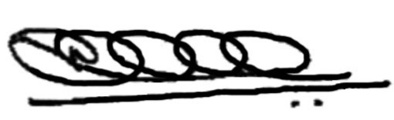
(K. VISHWANATH NAIK)
GENERAL SECRETARY.

PLEASE NOTE: This notice is given in advance to enable our members to plan and book their journey, to attend the Conference.

